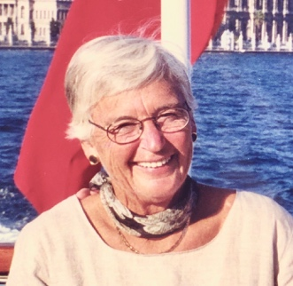

My dear friends,

I hope you all are well and are hanging in there during this uneasy time. Working in the garden seems to be one of the best remedies I’ve found for clearing my mind and calming my nerves, and I hope you all have found what works best for you.

I am sad to share the news that our sweet, sassy Cornie passed away on Friday evening (June 26, 2020). Our family is heartbroken, and we will all miss Mom terribly, but we are so very thankful to have been a part of her beautiful life. The great news is that, after several really tough months apart, Cathedral Village allowed us all to be with both Mom and Dad for several days before she left us. My sisters and I, Cornie’s grandchildren and her twin brother, Jim Parsly, will all cherish the precious time we had with her and she was at peace knowing that we were there to support Dad.

I want to be sure that you know that Cornie ADORED you all and was so proud to be a member of Wissahickon Garden Club. She loved all that she learned along the way and appreciated the opportunity to, in turn, support others who were eager to learn as well. As a newcomer, Cornie had the opportunity to learn from some of the very best: Susie Walker, Peggy Bowditch, Ann Hunter, Susie Stanley, Anne Coste, Susie Stauffer, Ginny Simonin, her sister-in-law Joly Stewart, just to name a few. Over the years, she always loved going to Tuesday morning meetings and trying her hand at small arrangements to enter in Club shows. She later gained the confidence to put together arrangements or a niche for the Philadelphia Flower Show on her own. While she enjoyed those challenges, Cornie relished the opportunity to work with others as a team, whether to plan and execute a larger entry for the Flower Show, work on a civic project together, or plan a special event to raise funds for a worthy project. She also loved visiting other members’ gardens to share tips and tricks or, more often, just to “ooh” and “aah” at their handiwork. She loved getting to know you all and your families. I was so honored to be invited to join the Club as well and it has always been something very special that Mom and I shared. I really miss it but, unfortunately, works gets in the way of those Tuesday morning meetings! Someday…

Mom was a “Lay Weeder” at St. Martin-in-the-Fields Church and, even if she had to crawl, was always there planting, pruning or tidying up the grounds. One of her favorite spots was the columbarium, which will be her final landing spot. Please stop by and chat with her sometime! I found a poem Cornie wrote years ago about her work there and what it meant to her. I thought I would share it because I know that you, most of all, will see her in it. And, well, we all could use a Cornie poem right about now!

Thank you all for your fabulous friendship. Sending lots of love from all the Walton’s.

Frida
There is power and peace in our garden
Where those who have gone before us lie
Caring for this space brings joy to my heart
And leaves me unafraid to die
For the beauty of all the changing seasons
The quiet communion with old friends who sleep there
Are only a few of the reasons
Why we tend this garden with such loving care
Bright with bulbs and buds in early spring
Full color is the summer and late fall show
Covered with a blanket of white in winter
Filled with the peace which we will know

